# Diabetes Classification Results using AdaBoost

## Classification Report:

precision recall f1-score support  
  
 0 0.75 0.69 0.72 153  
 1 0.70 0.76 0.73 147  
  
 accuracy 0.72 300  
 macro avg 0.72 0.72 0.72 300  
weighted avg 0.73 0.72 0.72 300

## ROC AUC Score:

ROC AUC Score (AdaBoost): 0.8132808679027166

## ROC Curve:

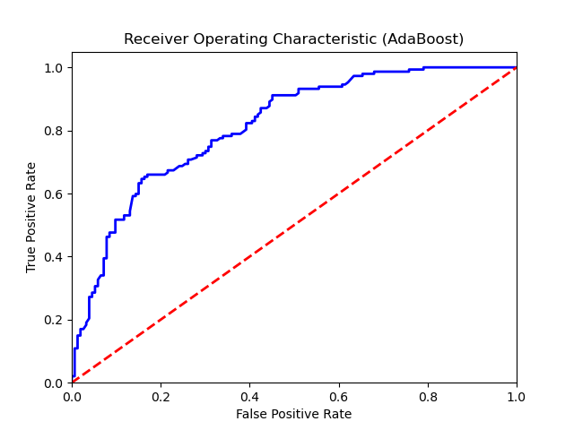

## Confusion Matrix:

True Negatives: 105

False Positives: 48

False Negatives: 35

True Positives: 112

## Confusion Matrix Plot:

